HAKKOTSU NO SHO (Letter on White Ashes)

In silently contemplating the transient nature of human existence, nothing in our world is more fragile and fleeting than our life. Thus, we hear of no one sustaining a human form for a thousand years. Life swiftly passes and who among us can maintain our human form for even a hundred years?

Whether I go before others, or others go before me; whether it be today, or it be tomorrow, who is to know? Those who leave before us are as countless as the drops of dew. Though in the morning we may have radiant health, in the evening we may return to ashes. When the winds of impermanence blow, our eyes are closed forever; and when the last breath leaves us, our face loses its color.

Though loved ones gather and lament, everything is to no avail. The body is then sent into an open field and vanishes from this world with the smoke of cremation, leaving only white ashes. There is nothing more real than this truth of life. The fragile nature of human existence underlies both the young and old, and therefore we must, one and all, turn to the teachings of the Buddha and awaken to the ultimate source of life.

By so understanding the meaning of death, we shall come to fully appreciate the meaning of this life which is unrepeatable and thus to be treasured above all else. By virtue of true compassion, let us realize the irreplaceable value of human life and let us together live the nembutsu in our hearts. Humbly and respectfully.



photo

Name
dod – dob
Years Old

Officiant: Rev. Satoshi Ka’imipono Tomioka
Puna Hongwanji Buddhist Temple
P.O. Box 100, Keaau, HI 96749
Telephone: 808-966-9981

Order of Memorial Service
Saturday, 2024

Officiant: Rev. Satoshi K. Tomioka
MC:

1. Opening Remarks

2. Opening Chant: Sanbujo (Three Respectful Calling)

3. Aspiration & Presentation of Dharma Name

4. Chanting of Sutra: “Shoshinge” & Offering of Incense

5. Gatha: “Mihotoke ni idakarete” / In Amida's Embrace”

6. Remembrance

7. Dharma Message & Reading of letter on White Ashes
8. Acknowledgements

9. Gatha: “Nembutsu”

10. Closing Remarks & Announcements

“Nembutsu”
Singing the Name of Amida Buddha who is embracing our departed loves ones and us warmly and gently. 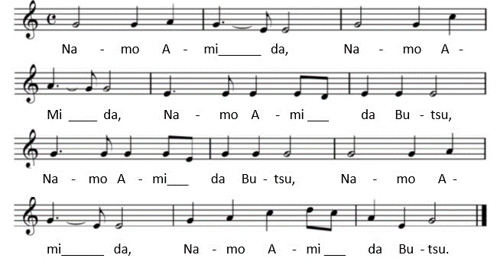
In Amida’s Embrace -Mihotoke ni Idakarete-
(Singable in both Japanese and English)

- Mi ho to ke ni, i da ka re te, ki mi yu ki nu ni shi no ki shi, Na tsu ka shi ki, o mo ka ge mo, ki e ha te shi, ka na shi sa yo

In Amida’s embrace, dear beloved one, you have gone beyond to the Western Shore. Fading memories of your image fond. Leave but emptiness: how we mourn your loss!

- Mi ho to ke ni, i da ka re te, ki mi yu ki un, ji hi no ku ni Mi su ku i wo, mi ni ka ke te, shi me shi ma su, ka shi ko sa yo

In Amida’s embrace, dear beloved one, you have gone beyond to the Land of Peace. You have shown to all in the highest form. ‘Mida’s Saving Vow: We owe gratitude

- Mi ho to ke ni, i da ka re te, Ki mi yu ki nu, ha na no sa to Tsu ki se za ru, ta no shi mi ni, E mi ta mō u re shi sa yo

In Amida’s embrace, dear beloved one, you have gone beyond to the Floral Realm. Oh! Your countenance beams with happiness. Inexhaustible: we rejoice for you!

- Mi ho to ke ni, i da ka re te, ki mi yu ki un, ta ma no i e U tsu ku shi ki, mi ho to ke to, na ri ma shi shi, to to sa yo

In Amida’s embrace, dear beloved one, you have gone beyond to the ‘Splendent Home. You’ve become at one with Amida’s Light. In the Buddhahood: we do you revere.

